 



Database Programming with SQL 12-1: INSERT Statements Practice Activities

# Objectives

* Give examples of why it is important to be able to alter the data in a database
* Construct and execute INSERT statements that insert a single row using a VALUES clause
* Construct and execute INSERT statements that use special values, null values, and date values
* Construct and execute INSERT statements that copy rows from one table to another using a subquery

# Vocabulary

Identify the vocabulary word for each definition below.

|  |  |
| --- | --- |
| **User** | Someone doing “real work” with the computer, using it as a means rather than an end |
| **transaction** | Consists of a collection of DML statements that form a logical unit of work. |
| **explicit** | Fully and clearly expressed; leaving nothing implied |
| **INSERT INTO** | Adds a new row to a table |

# Try It / Solve It

Students should execute DESC tablename before doing INSERT to view the data types for each column. VARCHAR2 data-type entries need single quotation marks in the VALUES statement.

1. Give two examples of why it is important to be able to alter the data in a database.

Создание и изменение логинов и паролей в базе данных

Хранение данных о сообщениях

1. DJs on Demand just purchased four new CDs. Use an explicit INSERT statement to add each CD to the copy_d_cds table. After completing the entries, execute a SELECT * statement to verify your work.

|  |  |  |  |
| --- | --- | --- | --- |
| **CD_Number** | **Title** | **Producer** | **Year** |
| 97 | Celebrate the Day | R & B Inc. | 2003 |
| 98 | Holiday Tunes for All Ages | Tunes are Us | 2004 |
| 99 | Party Music | Old Town Records | 2004 |
| 100 | Best of Rock and Roll | Old Town Records | 2004 |

INSERT INTO copy_d_cds(cd_number,title,producer,year)

VALUES(97,'Celebrate the Day','R & B Inc.','2003');

INSERT INTO copy_d_cds(cd_number,title,producer,year)

VALUES(98,'Holiday Tunes for All Ages','Tunes are Us','2004');

INSERT INTO copy_d_cds(cd_number,title,producer,year)

VALUES(99,'Party Music','Old Town Records','2004');

INSERT INTO copy_d_cds(cd_number,title,producer,year)

VALUES(100,'Best of Rock and Roll','Old Town Records','2004');

SELECT * FROM copy_d_cds ;

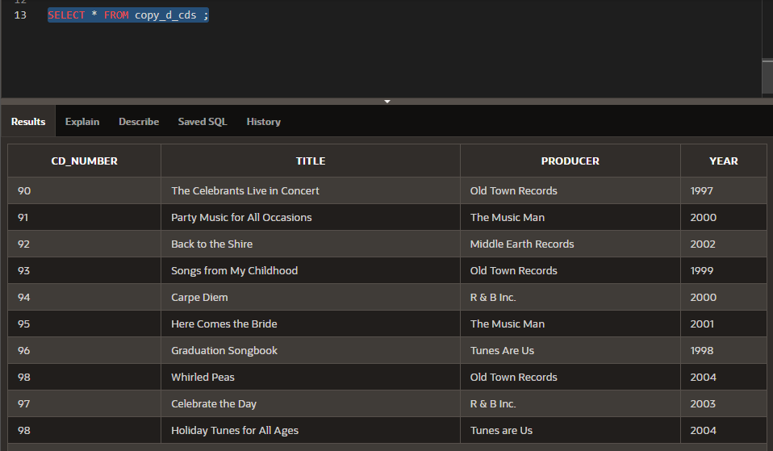

1. DJs on Demand has two new events coming up. One event is a fall football party and the other event is a sixties theme party. The DJs on Demand clients requested the songs shown in the table for their events. Add these songs to the copy_d_songs table using an implicit INSERT statement.

|  |  |  |  |
| --- | --- | --- | --- |
| **ID** | **Title** | **Duration** | **Type_Code** |
| 52 | Surfing Summer | Not known | 12 |
| 53 | Victory Victory | 5 min | 12 |

CREATE TABLE copy_d_songs

AS ( SELECT * FROM d_songs);

INSERT INTO copy_d_songs

VALUES(52,'Surfing Summer',NULL,NULL,12);

INSERT INTO copy_d_songs

VALUES(53,'Victory Victory','5 min',NULL,12);

SELECT * FROM copy_d_songs ;

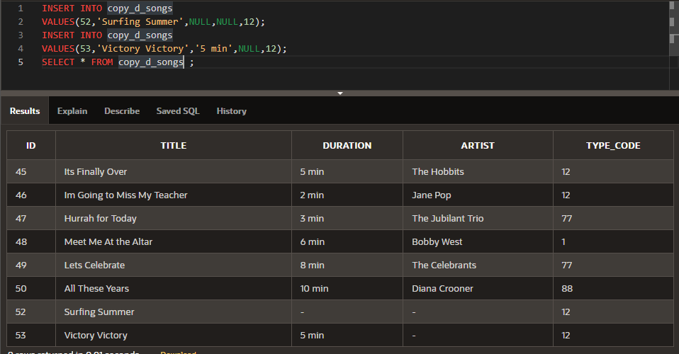

1. Add the two new clients to the copy_d_clients table. Use either an implicit or an explicit INSERT.

|  |  |  |  |  |
| --- | --- | --- | --- | --- |
| **Client_Number** | **First_Name** | **Last_Name** | **Phone** | **Email** |
| 6655 | Ayako | Dahish | 3608859030 | [dahisha@harbor.net](mailto:dahisha@harbor.net) |
| 6689 | Nick | Neuville | 9048953049 | [nnicky@charter.net](mailto:nnicky@charter.net) |

CREATE TABLE copy_d_clients

AS ( SELECT * FROM d_clients);

INSERT INTO copy_d_clients(client_number,first_name,last_name,phone,email)

VALUES(6655,'Ayako','Dahish',3608859030,'dahisha@harbor.net');

INSERT INTO copy_d_clients(client_number,first_name,last_name,phone,email)

VALUES(6689,'Nick','Neuville',3608859030,'nnicky@charter.net');

SELECT * FROM copy_d_clients ;

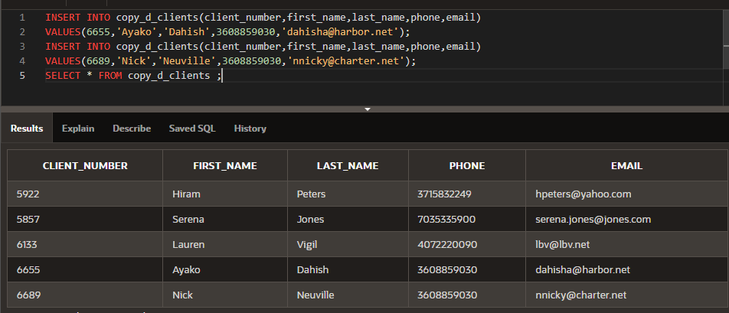

1. Add the new client’s events to the copy_d_events table. The cost of each event has not been determined at this date.

|  |  |  |  |  |  |  |  |  |
| --- | --- | --- | --- | --- | --- | --- | --- | --- |
| **ID** | **Name** | **Event_ Date** | **Description** | **Cost** | **Venue_ ID** | **Package_ Code** | **Theme_ Code** | **Client_ Number** |
| 110 | Ayako Anniversary | 07-Jul-  2004 | Party for 50, sixties dress, decorations |  | 245 | 79 | 240 | 6655 |
| 115 | Neuville Sports Banquet | 09-  Sep- 2004 | Barbecue at residence, college alumni, 100 people |  | 315 | 87 | 340 | 6689 |

CREATE TABLE copy_d_events

AS ( SELECT * FROM d_events);

INSERT INTO copy_d_events(id,name,event_date,description,cost,venue_id,package_code,theme_code,client_number)

VALUES(110,'Ayako Anniversary',TO_DATE('07-Jul-2004','dd-Mon-yyyy'),'Party for 50, sixties dress, decorations',0,245,79,240,6655);

INSERT INTO copy_d_events(id,name,event_date,description,cost,venue_id,package_code,theme_code,client_number)

VALUES(115,'Neuville Sports Banquet',TO_DATE('09-Sep-2004','dd-Mon-yyyy'),'Barbecue at residence, college alumni, 100 people',0,315,87,340,6689);

SELECT * FROM copy_d_events ;

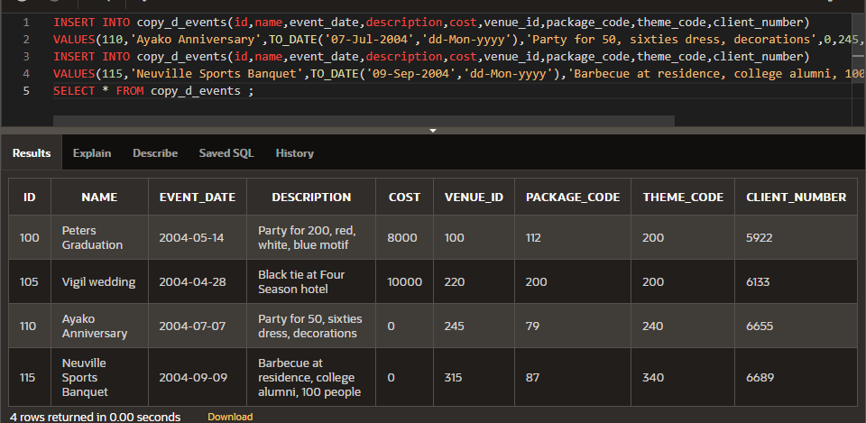

1. Create a table called rep_email using the following statement:

CREATE TABLE rep_email (

id NUMBER(3) CONSTRAINT rel_id_pk PRIMARY KEY,

first_name VARCHAR2(10), last_name VARCHAR2(10), email_address VARCHAR2(10))

Populate this table by running a query on the employees table that includes only those employees who are REP’s.

INSERT INTO rep_email(id, first_name, last_name, email_address)

SELECT employee_id, first_name, last_name, email

FROM employees

WHERE job_id LIKE '%\_REP' ESCAPE '\';

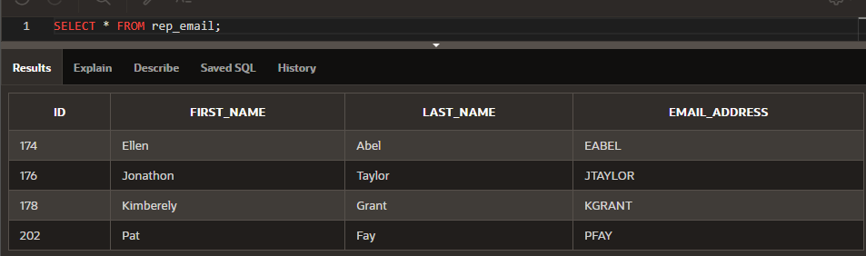

Copyright © 2020, Oracle and/or its affiliates. All rights reserved. Oracle and Java are registered trademarks of Oracle and/or its affiliates. Other names may be trademarks of their respective owners.